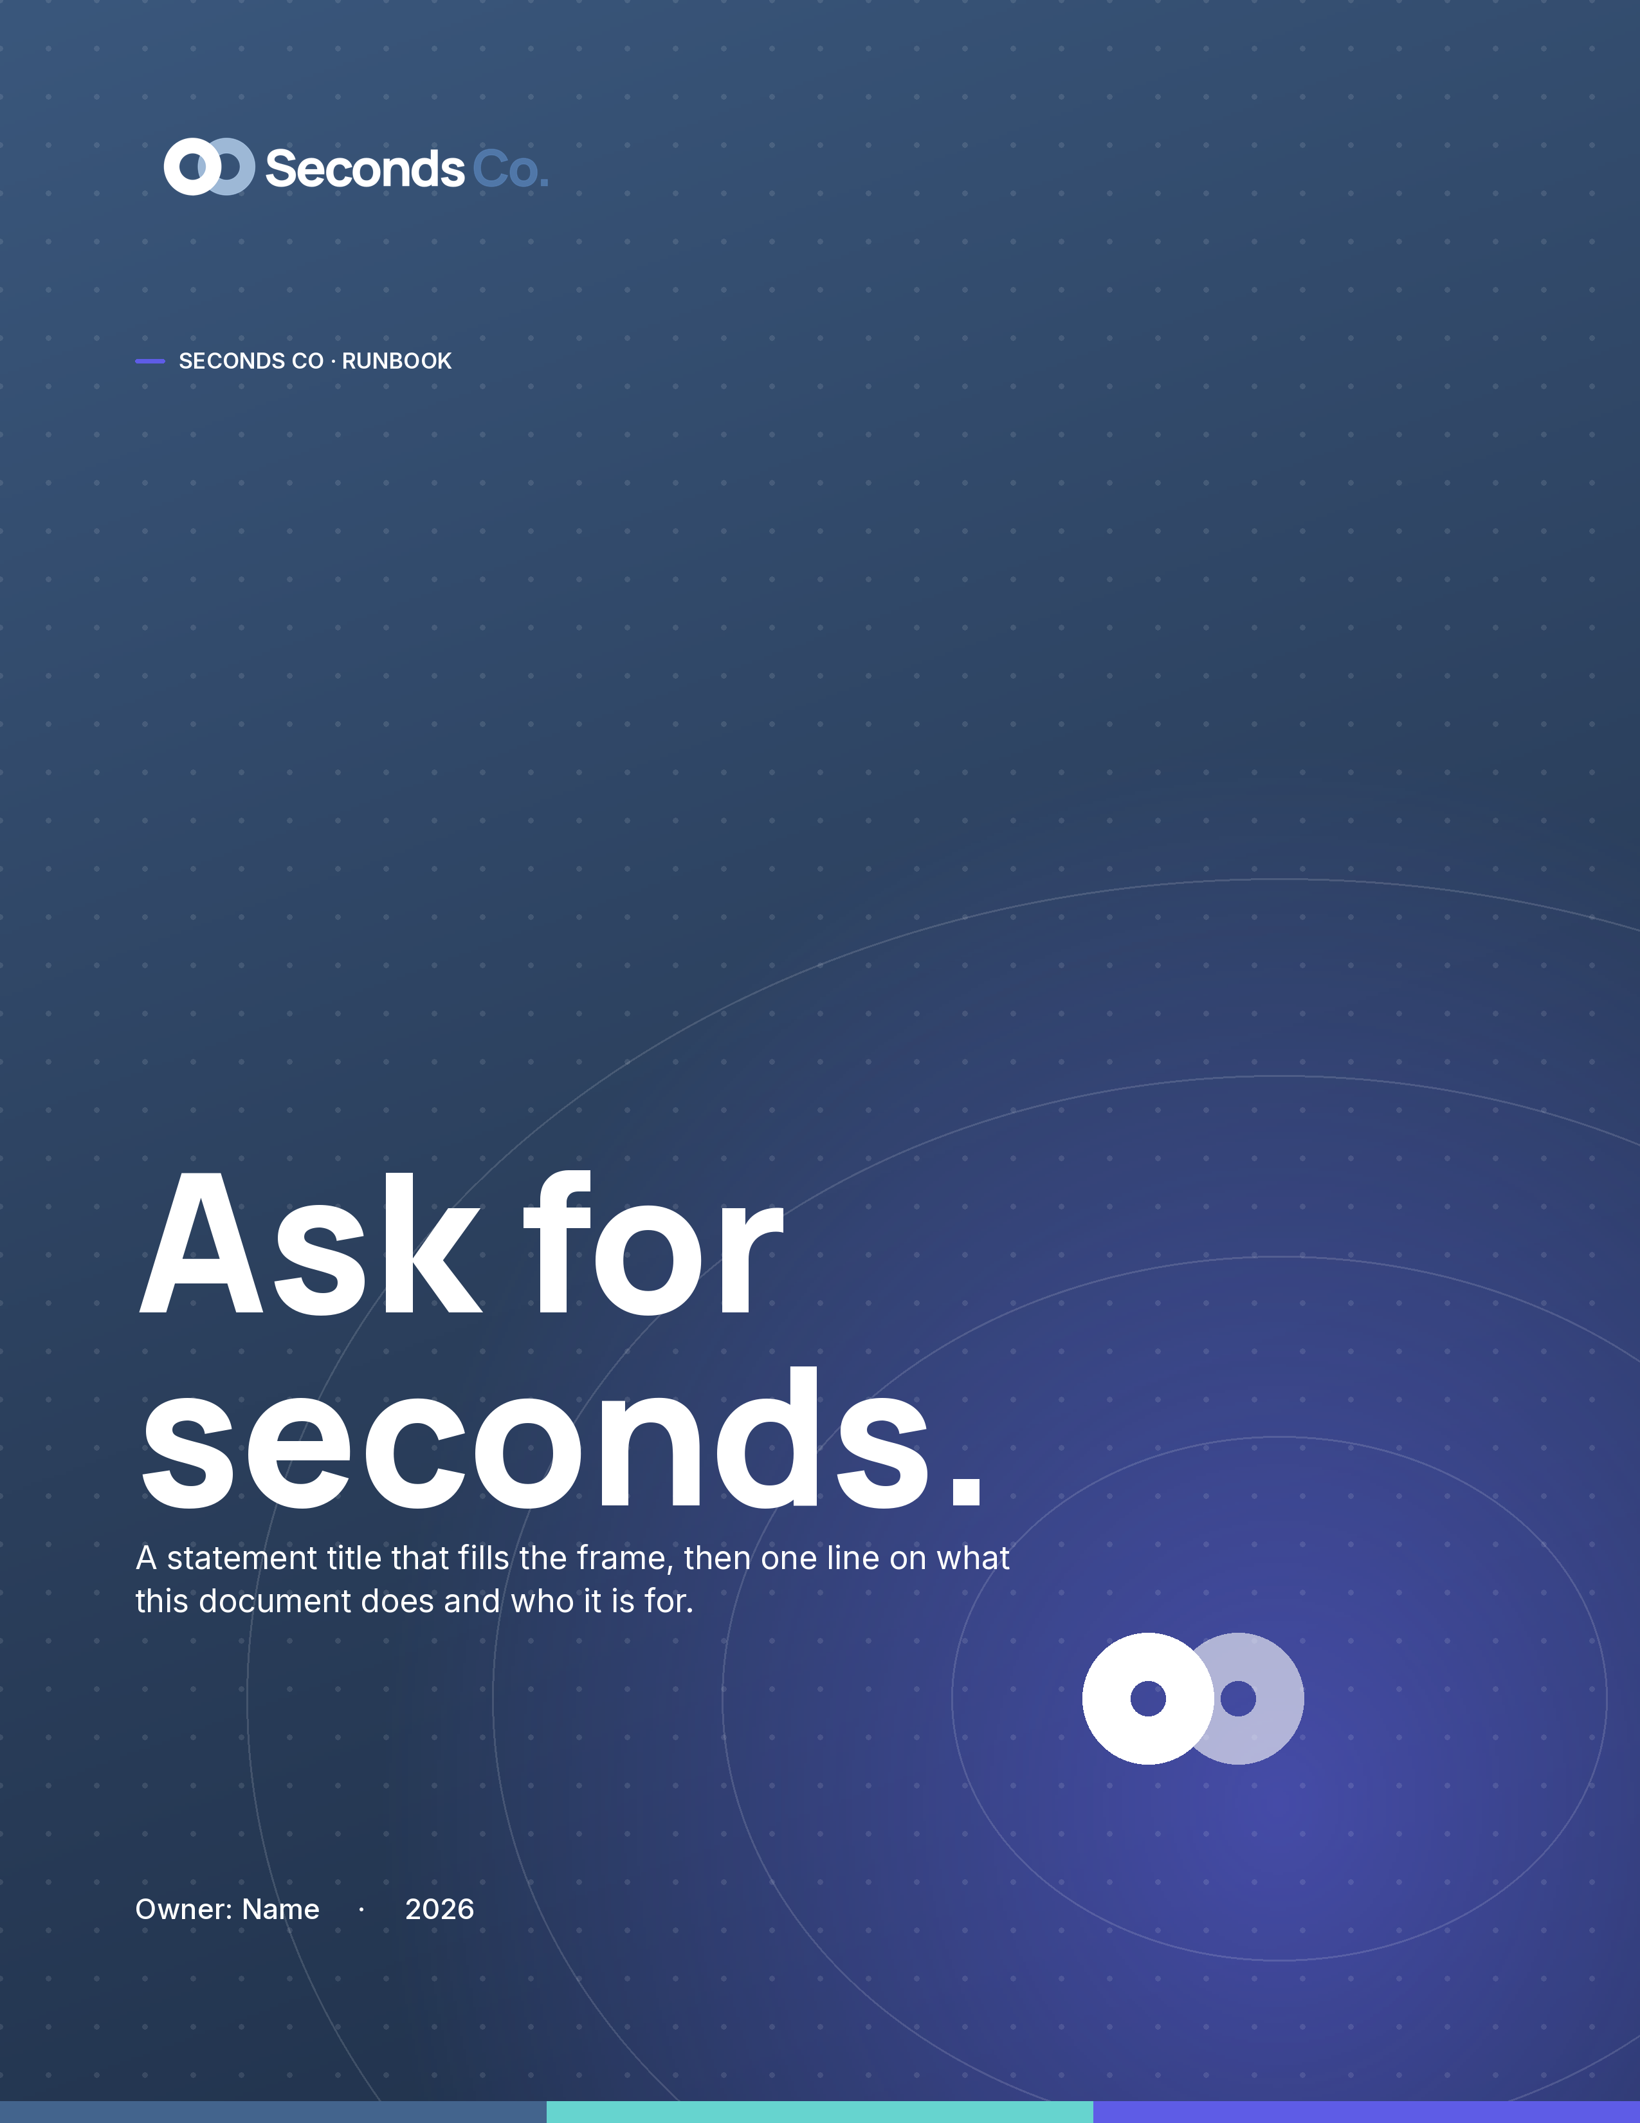

— SECTION 01
How we open.
This is the lede. One or two lines that set up the section, in Inter at a comfortable measure, before the body begins.
The morning, start to finish
This is the body style: Inter, ink, comfortable line height. Short sentences, one idea per paragraph. It should read like a person talking, not a policy talking.
Every new heading, table, and list you add inherits Manrope and Inter with Blue Aura colour, because the brand lives in the theme, not in one-off formatting.
“The highest compliment is seconds.”
Say the plain thing, then stop.
The steps
 Say what happened. One line, plainly. No preamble.
 Say what happens next. Name the owner and the date.
 Ask for seconds. If it worked, do it again.

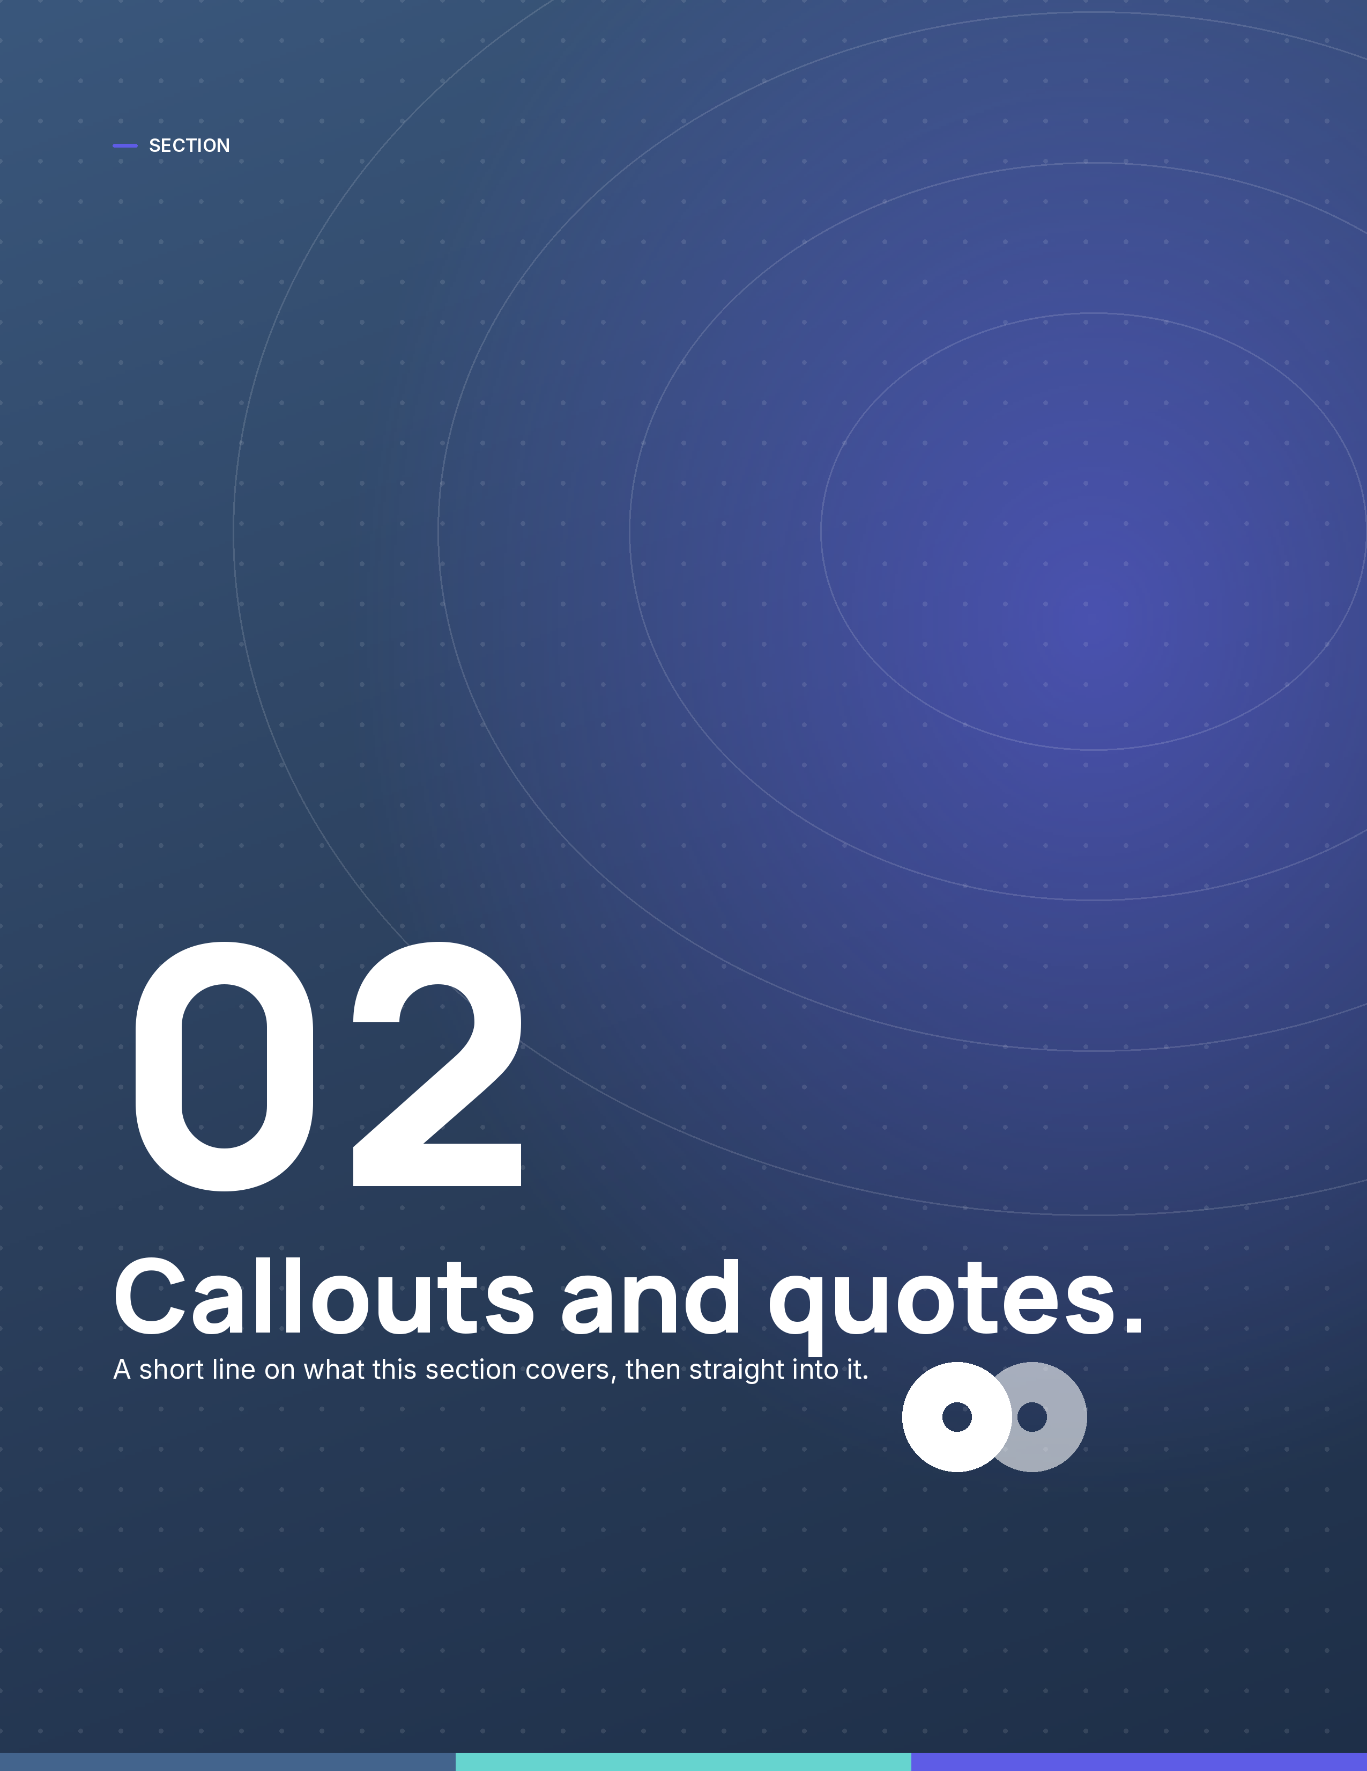

— SECTION 02
Callouts and quotes.
Tables inherit the theme too: a denim header row, hairline rules, tint banding.
Step | Owner | When
Open the day | Jason | 8:00
Clear the noise | Axis | 8:15
Ask for seconds | Team | EOD

